*What & Why of SOAP UI!*

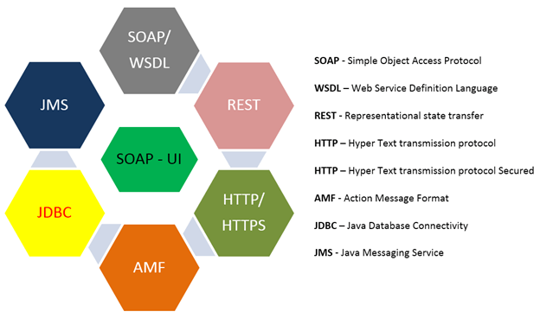

***What is SOAP UI?***

SoapUI is an open-source **web service testing application** for service-orientedarchitectures (**SOA**) and representational state transfers (**REST**). Its functionality covers web service inspection, invoking, development, simulation and mocking, functional testing, load and compliance testing.

* SoapUI is not meant for User Interface [Testing](https://qanalysisblog.wordpress.com/2017/06/18/testing-the-key-to-quality-development/). It is only used for WebAPI or WebService Testing.
* It is PROTOCOL Dependent and not browser or application dependent.
* SoapUI is not just a functional API testing tool but also help to perform non-functional testing such as performance and security test.

***Why to use SOAP UI?***

SoapUI helps ensuring that all data access (read and write) goes only through the [API](https://qanalysisblog.wordpress.com/2017/07/24/how-what-and-why-of-api-testing/) significantly simplifies security and compliance testing and thereby certification, since there is only one interface. It also ensures that all the required business rules are being enforced at the API tier allows time for much more complete user-experience tests once the UI is released, and not having to concentrate on testing every single business rule and path through the application near the end of the project. Lastly, it ensures that the API offers complete functionality allows for easy future expansion of the application as new business needs arise.

***What are benefits of API Testing using SOAP UI?***

Following are a few most important benefits of SoapUI that makes it a perfect candidate for [API Testing](https://qanalysisblog.wordpress.com/2017/07/24/how-what-and-why-of-api-testing/):

* **SoapUI has the most comprehensive Protocol Support** i.e
  + SOAP – Simple Object Access Protocol
  + WSDL – Web Service Definition Language
  + REST – Representational State Transfer
  + HTTP – Hyper Text Transfer Protocol
  + HTTPS – Hyper Text Transfer Protocol Secured
  + AMF – Action Message Format
  + JDBC- Java Database Connectivity
  + JMS – Java Messaging Service
* **SoapUI can be integrated very well with popular development and testing tools**
  + MAVEN – can execute SOAPUI tests within Maven Build using simple commands.
  + HUDSON – SOAPUI integrates with HUDSON, which helps to spot bugs quickly for each and every commit by the developers via continuous integration.
  + JUNIT – is a unit testing framework built in Java, which can control the flow of tests from SOAPUI as well.
  + APACHE ANT – Using SOAP UI’s Command line, tests within an ANT Automated Build can be executed.
* **SoapUI can be used for Functional Testing**
  + Its a powerful tool that allows testers to write Functional API Tests in SoapUI.
  + Supports Drag-Drop feature which accelerates the script development.
  + Supports debugging of tests and allows testers to develop data driven tests.
  + Supports Multiple Environments – Easy to switch between QA, Dev and Prod Environments.
  + Allows advanced scripting (tester can develop their custom code depending on the Scenario).
* **SoapUI can be used for Non Functional Testing like – Load or Security Testing**
  + Distribute the Load Tests across any number of loadUI Agents.
  + Simulate high volume and real-world load testing with ease.
  + Allows Advanced custom reporting to capture performance parameters.
  + Allows End-to-End System Performance Monitoring.
  + Has the capability to perform a complete set of vulnerability scan.
  + Prevents SQL Injection to secure the databases.
  + Scans for Stack overflows that are caused by documents huge in size.
  + Scans for Cross Site Scripting, which usually occurs when service parameters are exposed in messages.
  + Performs Fuzzing scan and Boundary scan to avoid erratic nature of the API services.

*If you like my posts on*[*Software Testing*](https://qanalysisblog.wordpress.com/2017/06/18/testing-the-key-to-quality-development/)*and*[*Quality Analysis*](https://qanalysisblog.wordpress.com/2017/06/16/25bestqapractices/)*, please support by subscribing or sharing my blog (*[***https://qanalysisblog.wordpress.com***](https://qanalysisblog.wordpress.com/)***)****.Feel free to share your thoughts in the comments section below as I learn just as much from you as you do from me.*